COLOR PALETTE PICKER
@CREATIVITY THINK (9483175986/7019689991)

ABSTRACT:
Color Palette Picker is a dynamic web application designed to assist users in choosing, generating, and managing color palettes for design and UI projects. Users can select colors manually or generate palettes automatically, view corresponding hex and RGB values, and copy or save the palettes for later use. Developed using Django for backend support and React with Axios for frontend interactions, the platform provides an intuitive and interactive interface suitable for designers, developers, and hobbyists needing a fast and practical color planning tool..

INTRODUCTION OF THE PROJECT:
Effective color selection is essential in web design, UI/UX projects, and creative experiments. Traditional methods often involve manual color picking from design software or static resources, which can be time-consuming. Color Palette Picker addresses these challenges by offering a dynamic tool that allows instant generation and selection of color palettes, displaying accurate hex and RGB codes, and enabling users to copy or save palettes for project use. The platform simplifies color management and enhances productivity for designers and developers..

PROJECT OBJECTIVES:

• Allow users to pick or generate color palettes dynamically
• Display accurate hex and RGB values for selected colors
• Enable users to copy or save palettes for future reference
• Provide an interactive and responsive frontend interface
• Support quick experimentation and design planning
• Ensure smooth backend-frontend communication via Django and Axios
• Offer a lightweight and easy-to-use platform
• Assist users in efficient UI and web project color management

PROBLEM OF THE STATEMENT:
Designers and developers often struggle to select and manage consistent color schemes for projects. Manual color picking and conversions between hex and RGB values are inefficient and prone to errors. Color Palette Picker solves these problems by providing a web-based dynamic solution for generating, viewing, and saving color palettes accurately and interactively, ensuring productivity and design consistency..

MOTIVATION OF THE PROJECT:
• To provide a quick and efficient color palette tool for design projects
• To improve accuracy in color selection and conversion between hex/RGB
• To simplify color management for web and UI design workflows
• To offer a dynamic and interactive user interface
• To demonstrate integration between Django backend and React frontend
• To provide a lightweight tool that is easy to deploy and maintain
• To support designers, developers, and creative learners in color experimentation

BLOCK DAIGRAM OF PROJECT:

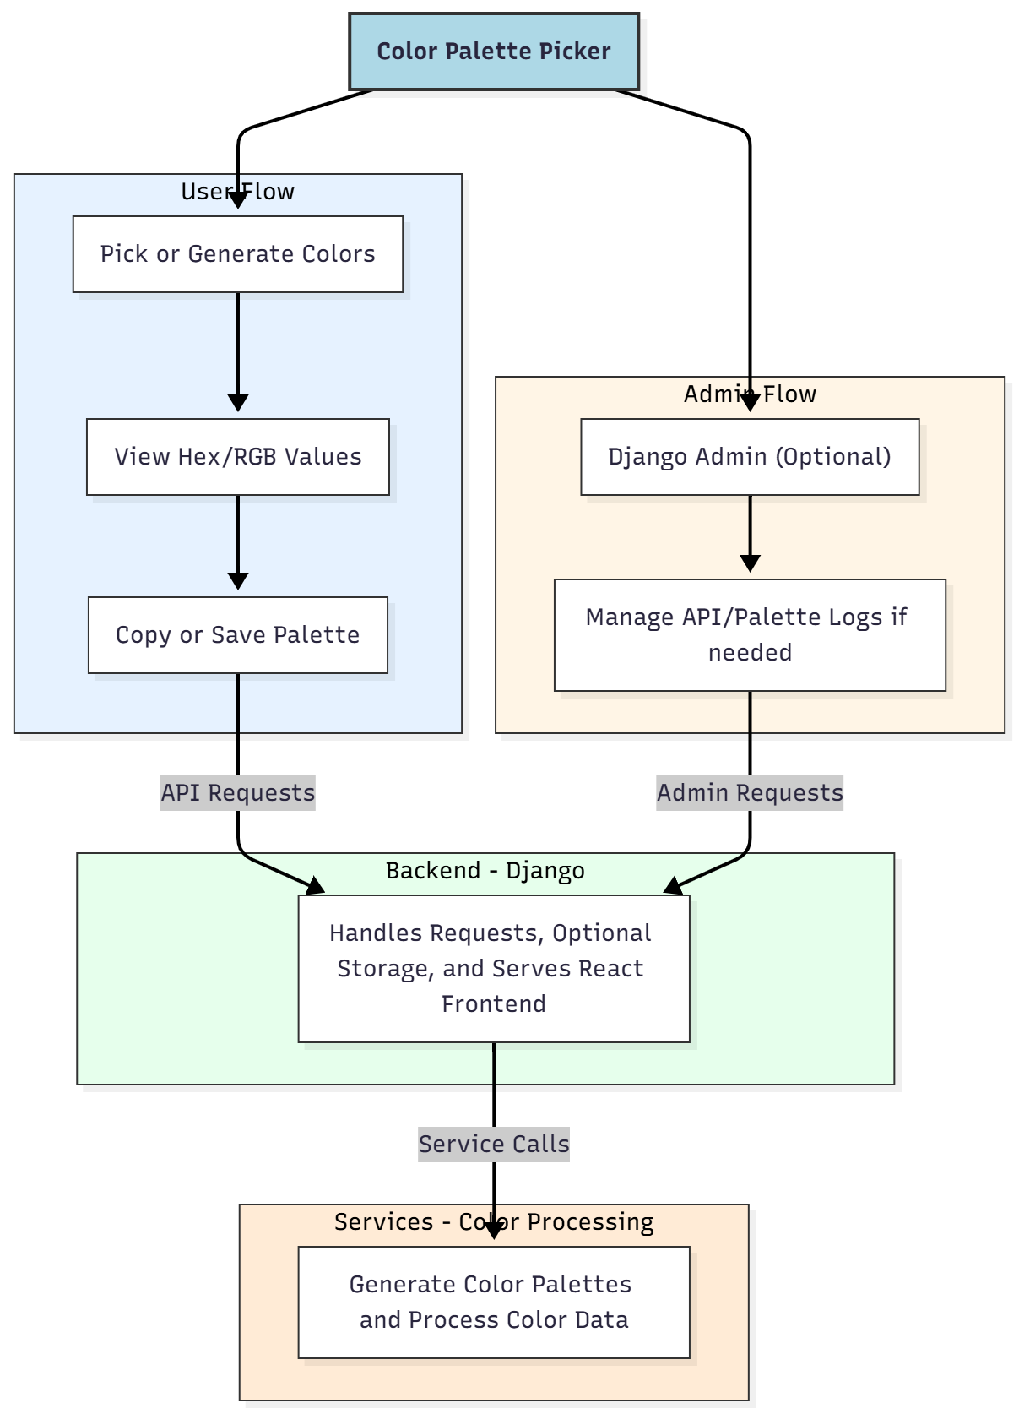

WORKING OF THE PROJECT:
Users start by selecting colors manually or generating palettes automatically. The frontend React application communicates via Axios with the Django backend, which processes requests and optionally stores palette information. Users can view corresponding hex and RGB values and copy or save palettes for later use. Admins, if required, can use Django admin to manage logs or API configurations. The workflow ensures an interactive, dynamic, and accurate platform for color selection and palette management..

SOFTWARE REQUIREMENT:
- Backend:
  - Python 3.x
  - Django
  - Django REST Framework
  - SQLite/PostgreSQL
- Frontend:
  - Node.js and npm
  - React.js
  - Axios
- Development Tools:
  - Visual Studio Code
  - Postman (for testing APIs)
  - Git/GitHub (for version control)
- Server/Deployment (Optional):
  - Gunicorn, Nginx, or Heroku/AWS for hosting

ADVANTAGES OF THE PROJECT:

• Dynamic color palette generation and selection
• Accurate hex and RGB representation
• Easy copy and save options for palettes
• Lightweight and responsive interface
• Optional admin control for logs or API management
• Suitable for designers, developers, and learners
• Simple deployment and minimal maintenance
• Enhances productivity in UI and web design projects

APPLICATIONS OF THE PROJECT:
• Web and UI design experimentation
• Quick color palette planning for projects
• Learning projects involving React and Django integration
• Small embedded color widgets on websites or dashboards
• Creative exercises for designers and developers

REFERENCES:

- Django REST Framework Documentation — Django Software Foundation. Django Documentation. Available: https://docs.djangoproject.com/
- Django REST Framework. DRF Documentation. Available: https://www.django-rest-framework.org/
- React. React Official Documentation. Available: https://reactjs.org/docs/getting-started.html
- Redux. Redux Documentation. Available: https://redux.js.org/introduction/getting-started
- PostgreSQL Global Development Group. PostgreSQL Documentation. Available: https://www.postgresql.org/docs/
- MySQL. MySQL Reference Manual. Available: https://dev.mysql.com/doc/
- Git. Git Documentation. Available: https://git-scm.com/doc
- Node.js. Node.js Documentation. Available: https://nodejs.org/en/docs/
- Axios. Axios Documentation. Available: https://axios-http.com/docs/intro
- Socket.io Documentation – https://socket.io/docs/

